- https://apac.ingrammicro.com/ekyc/

- Home page of eKYC portal.
Click “Sign-Up” option given at the bottom of the Page.
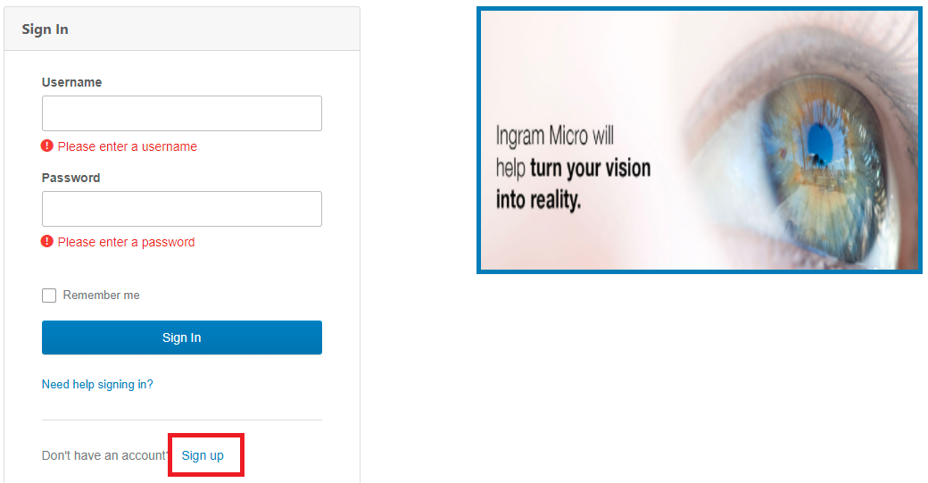

- Find below the Sign-Up process:
- Fill the below fields and click “Register”.
- Details entered cannot be modified later. Double check the credentials before clicking “Register” Button.
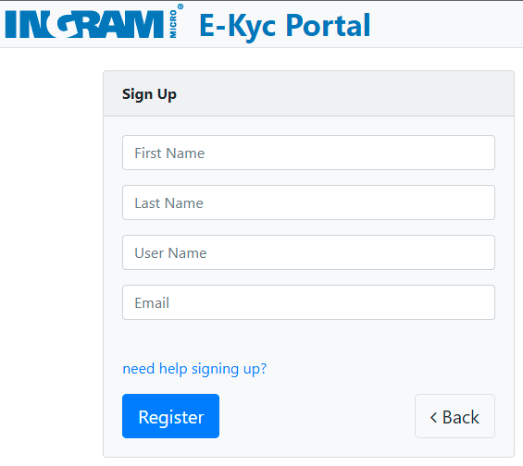
User Name
Registered mail Id
- After completing Sign-Up Process, Verification mail is sent to your Registered mail Id.
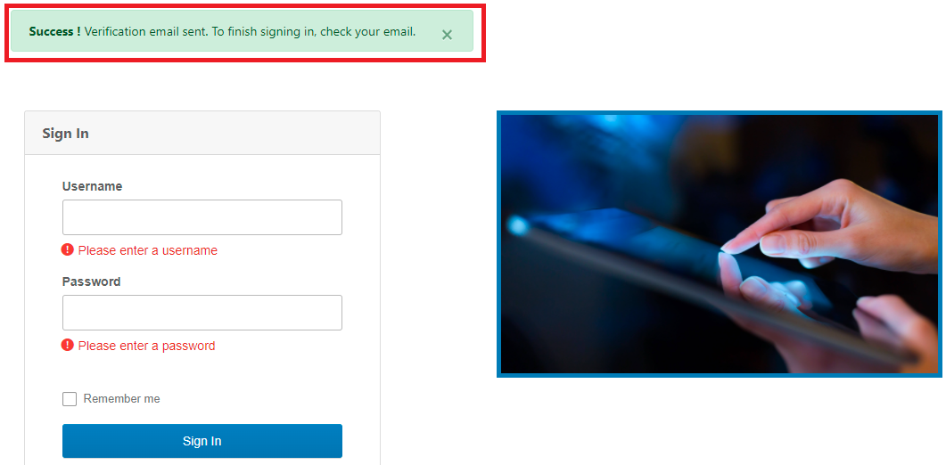

- Mail sent to your Registered mail Id contains User Name and link to “Activate Okta Account”
Click the field highlighted in RED.
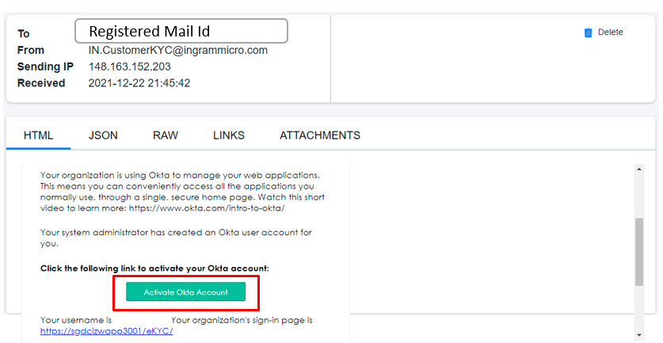
Username is here

To be continued in next page……………………………………………………………..

- Below screen appears after Activating Okta Account.
Type Password you would like to enter at sign-in and Click “Create My Account” button.

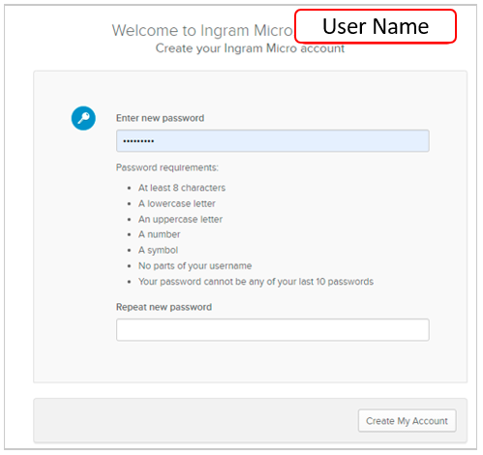
- After creating the Account, Weblink automatically directs you to the Log-In page.
For User Name, Refer mail subjected “Ingram Micro - Welcome to eKYC!”

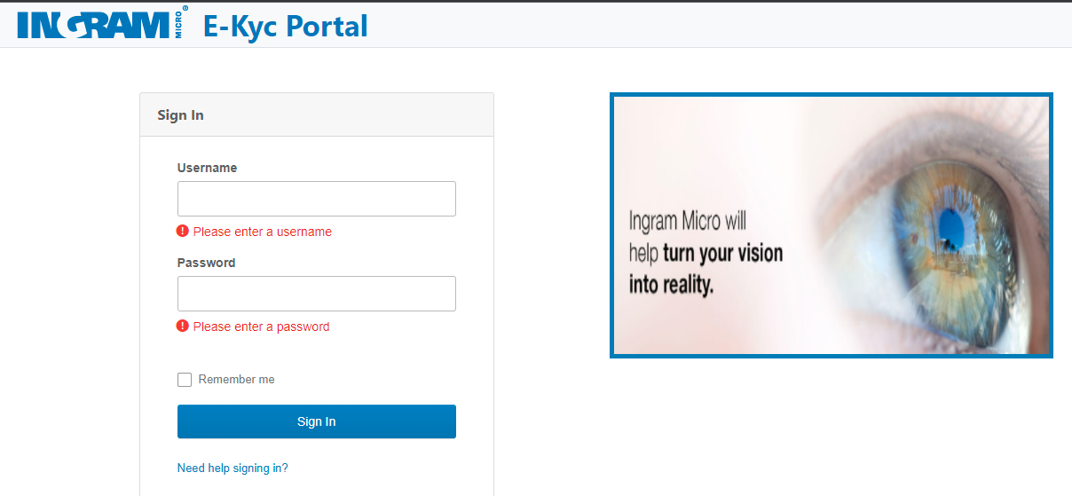

- After Logging in, Referral page pops-up.
If referred by Ingram Sales Associate, Fill the details and click Save. Else Click “Close” Button.
You can now access Online Form for filling the KYC details

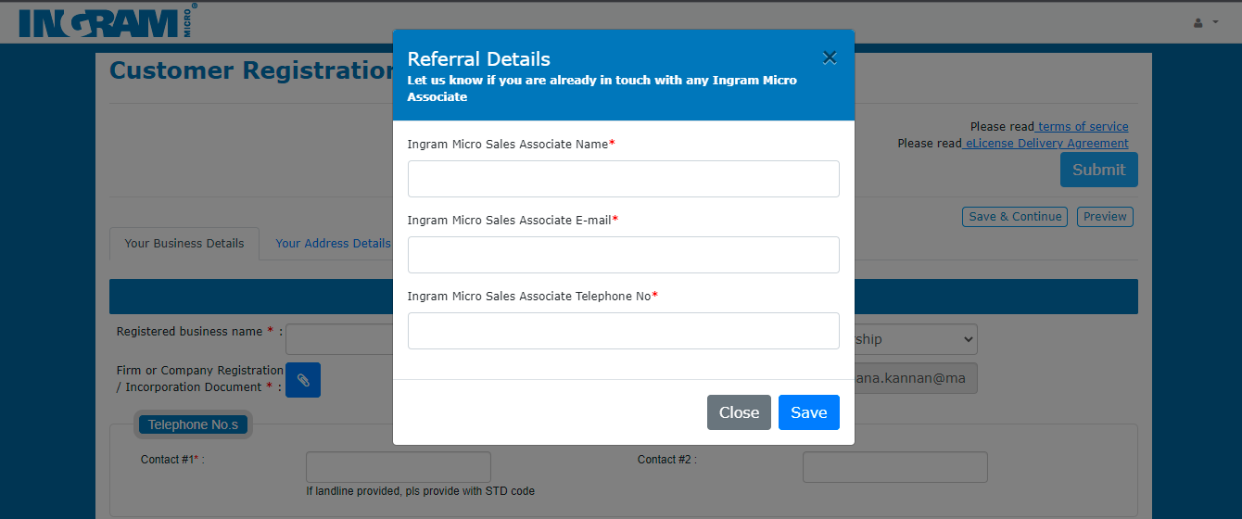

Retrieve the Password thru’ Forgot Password functionality
- Click the option highlighted in RED – Need help signing in?
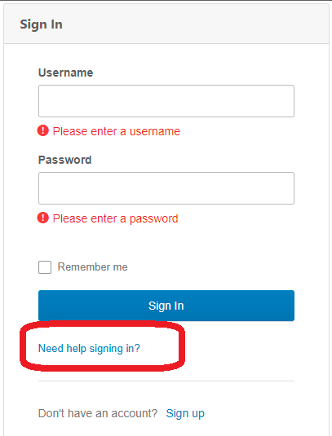
- Click the option highlighted in RED – Forgot Password?
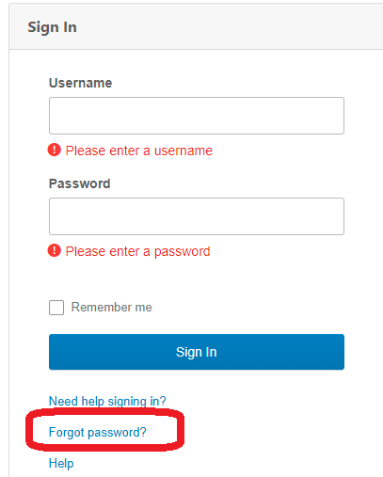

- Ener username and click “Submit”
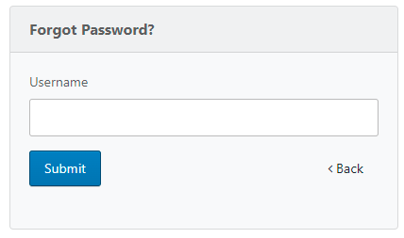

- Upon seeing the pop-up message, kindly check your Registered mail Id.
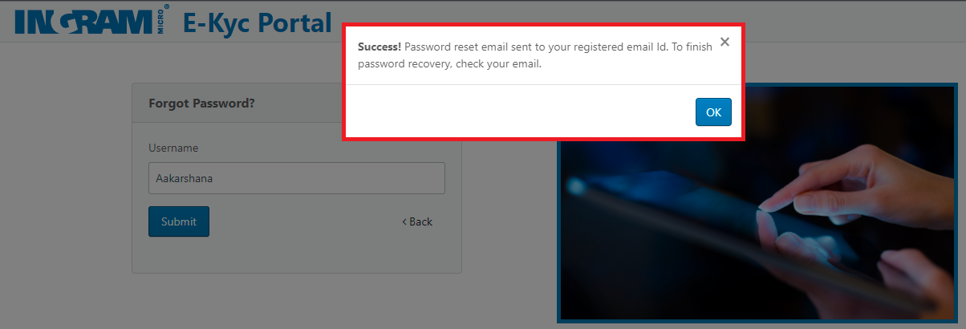

- Click the field highlighted in Red – Reset Password

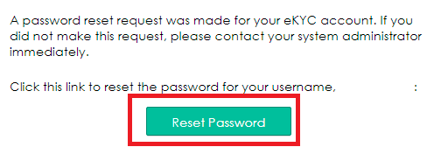

- Type the New Password you’d like to enter at Log-In and click “Reset Password”
